**AP Questions Tay/Mac #1** Name:__________________________________

1) Use a 6th degree Maclaurin polynomial to approximate cos(.4)

2) What are all values of x for which the series converges?

(A) -e < x ≤ e

(B) -1 ≤ x < 1

(C) -e ≤ x < e

(D) -1 < x ≤ 1

(E) -1 ≤ x ≤ 1

3) The Taylor series for  centered at x = 0 is

(A)  (B)  (C) 

(D)  (E) 

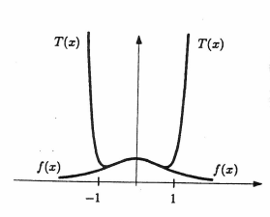4) The figure to the right shows the graph of y = f(x) and y = T(x) where T(x) is a Taylor polynomial for f(x) centered at zero. Which of the following statements are true?

I. T(0.5) is a good approximation for f(0.5)

II. T(1.5) is a good approximation for f(1.5)

III. T(0) = f(0)

(A) I only  
(B) II only  
(C) III only  
(D) I and III only  
(E) I, II, and III

5) The first three nonzero terms in the Taylor series about x = 0 of xe-x are

(A)  (B)  (C)  (D)  (E) 

6) For all x if f(x) = , then f’(x) =

(A)  (B)  (C) 

(D)  (E) 

7) Let E be the error when the Taylor polynomial T(x) = is used to approximate f(x) = sinx at x = 0.5. Which of the following is true?

(A) |E| < 0.0001 (B) 0.0001 < |E| < 0.0003 (C) 0.0003 < |E| < 0.005

(D) 0.005 < |E| < 0.007 (E) 0.07 < |E|

(8) The Taylor Series of a function f(x) about x = 3 is given by  
 

What is the value of f’’’(3)?

(A) 0  
(B) 1.167  
(C) 2.5  
(D) 5  
(E) 7