Calculus Section 9.1 Sequences  
-List the terms of a sequence and write a sequence.  
-Determine whether a sequence converges or diverges

Homework: page 592 #’s 1 – 7 odd, 18, 19, 29 – 49 odd

Mathematically, a **sequence** is defined as a function whose domain is the set of positive integers. Each integer is mapped to a term of the sequence.   
 1, 2, 3, 4, 5, … n, …  
  
 a1 a2 a3 a4 a5 … an …  
The numbers a1, a2, a3, …, an, … are the **terms** of the sequence. The number an is called the **nth term** of the sequence, and the entire sequence is notated using curly-brackets: {an}.  
**Example)** List the terms of each sequence:  
1) {an} = {3 + (-1)n} 2) {an} = 3) {dn} is dn+1 = dn – 5, d1 = 25

A primary focus of this chapter concerns sequences whose terms approach limiting values. These sequences are said to **converge**. For instance, the sequence $\left\{\frac{1}{2^{n}}\right\}$ converges to 0.

Evaluate $\lim_{n→∞}\left\{a_{n}\right\}$ to determine whether (and to what) a sequence converges.

**Example) Determine whether each sequence converges**1) {an} = {3 + (-1)n} 2) {bn} =  3) {cn} = 

4) {an} = 5) {bn} = 6) {cn} =

**Properties of Limits of Sequences**Let .  
1)  2)   
3)  4) 

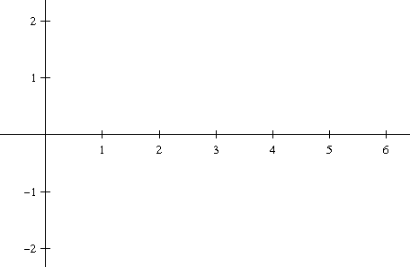**Squeeze Theorem for Sequences**If and there exists an integer N such that  
an ≤ cn ≤ bn for all n > N, then .

**Example)** Show that the sequence {cn} = converges, and find its limit.

**Find the nth Term of a Sequence**Find a sequence {an} whose first five terms are … then determine the value of a6 and whether the sequence converges or diverges.