Calculus Section 7.2 Volume by Disk Method  
-Find the volume of a solid of revolution using the disk method

Homework: page 453 #’s   
1, 3, 7, 9, 16, 19, 24, 33

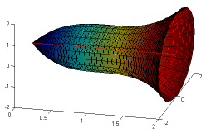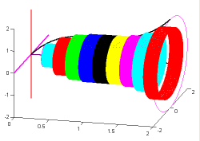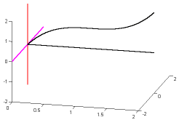Another way to create a 3-dimensional region is by rotating a function   
around a line. The rotation creates circular cross-sections that combine   
to create the volume. The resulting solid is called the **solid of revolution**,   
and the line that it revolved around is called the **axis of revolution**.   
The area of each circle is A = πr2, where r is distance from   
the function to the axis of revolution.

w

Axis of revolution

R

R

w

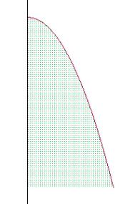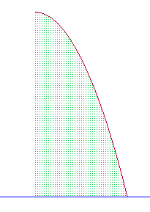**The Disk Method**To find the volume of a solid of revolution with the disk method, use one of the following formulas:  
Horizontal Axis of Revolution Vertical Axis of Revolution

**Example) Using the Disk Method x-axis**Find the volume of the solid formed by revolving the region bounded by the graph of  and the x-axis from [0, π] about the x-axis.

**Example) Using the Disk Method y-axis**Find the volume of the solid formed by revolving the region bounded by the graph of y = x2 + 1 and the y-axis for 1 ≤ y ≤ 5 about the y-axis.

**Example) Revolving About a Line That is Not a Coordinate Axis**Find the volume of the solid formed by revolving the region bounded by  and g(x) = 1 about the line y = 1.

**Example)**   
Find the volume of the solid formed by revolving the region bounded by y = $\sqrt{x+1}$, y = 3, and x = -1 about the line x = -1.

**Example)**Find the volume of the solid formed by revolving the region bounded by y = x2, the x-axis, and x = 2 about the line x = 2.

**Example)**Find the volume of the solid formed by revolving the region bounded by y = x2, y = 4, and the y-axis, about the line y = 4.