Calculus Section 7.1 Area Between Two Curves Part II
-Find the area of a region between two curves using integration
Homework: page 442 #’s 5, 6, 21, 25, 27, 34calc, 65, 66, 68
Review: to find the area between two curves, you always write the integral as __________ minus __________.
Some pairs of functions intersect at more than one point. As a result, the function that we would consider the upper function can switch and become the lower function for some interval. If this occurs, you must write as many integrals as you have switches.
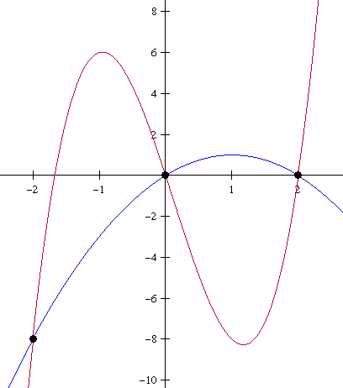
Example)
Find the area of the region between the graphs of f(x) = 3x³ – x² – 10x and g(x) = -x² + 2x.

If a function is written in terms of y, it is often most convenient to represent the area as an integral with respect to y. If that is the case, instead of upper – lower you will have ___________________________.
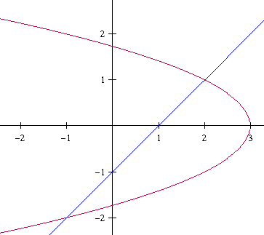
Example)
Find the area of the region bounded by the graphs of f(y) = 3 – y² and g(y) = y + 1.

