Calculus Section 5.3 Inverse Functions
-Verify that one function is the inverse function of another
-Determine whether a function has an inverse
Homework: page 343 #’s 1, 5, 7, 35-41 odd (only part a), 47, 87, 89-92
Definition of the Inverse of a Function
A function g is the inverse function of the function f if _____________ and ______________.
If g is the inverse of f, then f is __________________________.
The function g is denoted by f⁻¹(x).
A function does not have to have an inverse function, but if it does, the inverse function is ___________.
If a function has an inverse, then the inverse can be found by switching the x and y variables and solving for y.
Example)
Find the inverse of f(x) = 2x³ – 1 and verify they are inverses using composition.

Existence of an Inverse Function: The Horizontal Line Test
If any horizontal line crosses a function more than once, then the function fails the horizontal line test and does not have an inverse function.
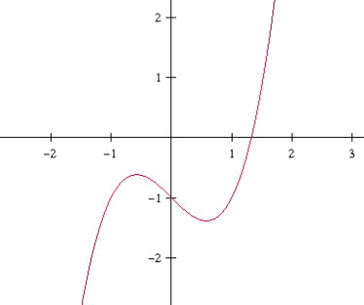
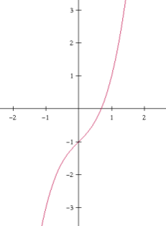
x³ + x – 1 x³ – x – 1

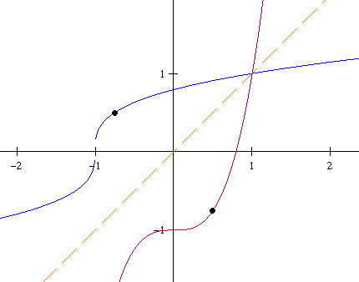
Properties on a Function and Its Inverse
1) If f is continuous on its domain, then f ⁻¹ is __________________ on its domain.
2) If f is increasing on its domain, then f ⁻¹ is __________________ on its domain.
3) If f is decreasing on its domain, then f ⁻¹ is __________________ on its domain.
4) If f is differentiable on an interval containing c and,
then f ⁻¹ is __________________ at f(c).
5) If f contains the point (a,b), then f ⁻¹ contains the point __________.
6) The graphs of f and f⁻¹ are reflections over the line ___________.

