Calculus Section 3.2 Rolle’s Theorem and the Mean Value Theorem

Homework: Rolle’s Thm and Mean Value Thm worksheet

-Understand and use Rolle’s Theorem  
-Understand and use the Mean Value Theorem

**Rolle’s Theorem**Let *f* be continuous on the closed interval [a, b] and differentiable on the open interval (a, b). If ___________________, then there is at least one number *c* in (a, b) such that.

***Visual Representation of Rolle’s Theorem:***

Examples)  
Show that Rolle’s Theorem applies to on the interval [1, 2]. Find the value of c guaranteed by Rolle’s Theorem.

**The Mean Value Theorem**If *f* is continuous on the closed interval [a, b] and differentiable on the open interval (a, b), then there exists a number *c* in (a, b) such that  
 .

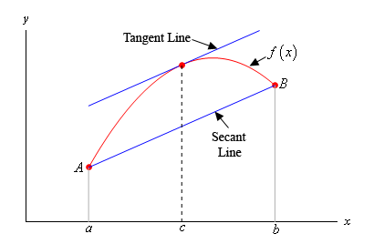This means there exists at least one point in the interval (a, b) where the slope of the tangent line is equal to the slope of the secant line drawn between the two endpoints.

This also means that there exists at least one point where   
the instantaneous slope is equal to the average slope on   
the interval.

Examples)

Suppose that we know that f(x) is continuous and differentiable on [6, 15]. We also know that f(6) = -2 and   
f ‘(x) ≤ 10 for the interval. What is the largest possible value for f(15)?

Determine all the numbers c which satisfy the conclusion of the Mean Value Theorem for f(x) = x3 + 2x2 – x on [-1, 2].

Ben rides a unicycle back and forth along a straight east-west track. The twice differentiable function B models Ben’s position on the track. The table below gives values for B(t) and Ben’s velocity, v(t).   
For 40 ≤ t ≤ 60, must there be a time t when Ben’s velocity is 2 meters per second? Justify your answer.

