Calculus Section 3.1 Extrema  
-Understand the definition of extrema of a function on an interval.  
-Understand the definition of relative extrema.  
-Find extrema on a closed interval.

Homework: Page 167 #’s 11 – 25 odd, 53, 63 – 66

**Definition of Extrema**Let *f* be defined on an interval I containing c.  
1. f(c) is the **minimum of *f* on I(min)** if __________________ for all x in I.  
2) f(c) is the **maximum of *f* on I** **(max)** if __________________ for all x in I.  
The minimum and maximum of a function on an interval are the **extreme values**, or **extrema**, of the function. The minimum and maximum of a function are also called the ____________________________ and ____________________________.

**The Extreme Value Theorem**  
If *f* is continuous on a closed interval [a, b], then *f* has both a minimum and a maximum on the interval.

*f* has to be continuous on the interval. _________________ do not qualify for maximums or minimums.

**Examples)**

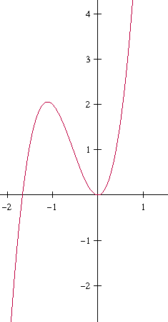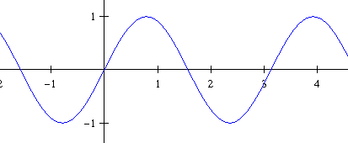**Relative Extrema  
Relative maximums** and **relative minimums** can occur inside an interval. Relative maximums are like the top of a __________ and relative minimums are the bottom of a ______________. There can be infinitely many relative maximums and relative minimums on an interval, but there is only one value for the absolute max and absolute min.

A relative extrema can be equal to the absolute extrema.

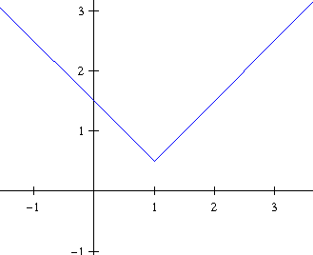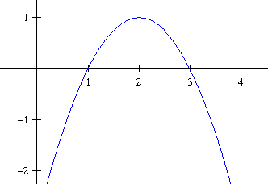**Definition of Critical Numbers**Let *f* be defined at *c*. If or if *f* is not differentiable at c, then c is a **critical number** of *f*.

Relative extrema can only occur at _______________________.   
If *f* has a relative minimum or maximum at x = c, then *c* is a critical number of *f*.

**Finding Extrema on a Closed Interval**The absolute minimum and maximum of a function will be found at either critical numbers or the endpoints of the interval. Always check all values.  
**Example)** Find the absolute max/min of  on the interval [-1, 2].

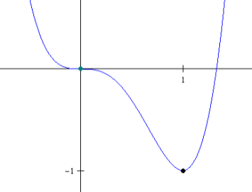To the left is the graph of. Notice that the critical point zero does not yield a relative maximum or minimum. So, critical numbers do not have to produce extrema.

**Example**Find the absolute max/min of on the interval [-1, 3].  
  
**Example**   
Find the absolute max/min ofon [0, 2π].