Calculus Section 7.1 Area Between Two Curves  
-Find the area of a region between two curves using integration

Homework: page 442 #’s 1-4, 17, 19, 23, 71

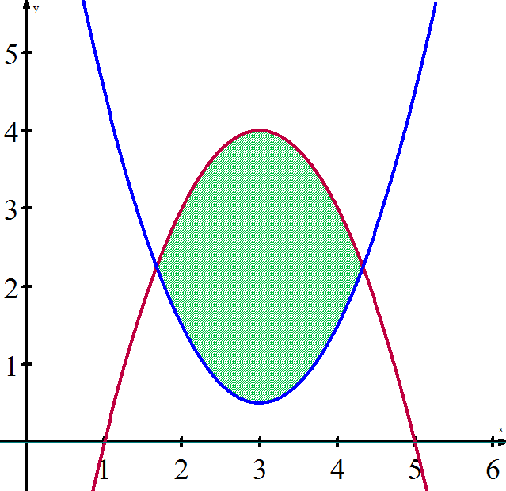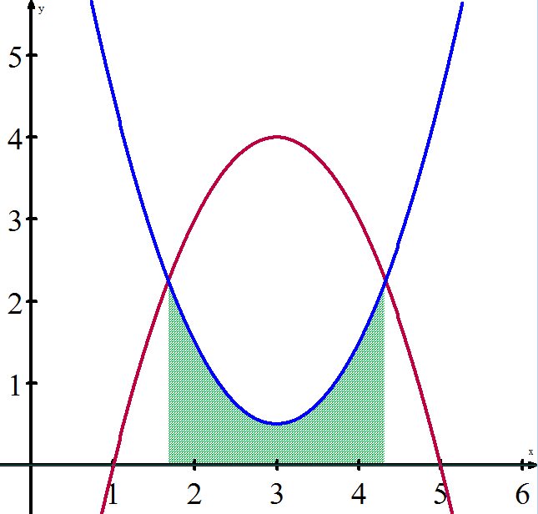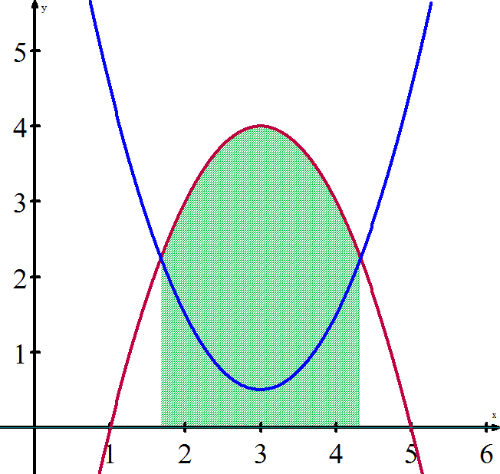We can extend the idea of definite integrals finding the area of a region *under* a curve to the area of a region *between* two curves. If two functions are both continuous on an interval [a, b], then the region between the curves can be found by subtracting the area of the upper region and the area of the lower region.

Area of upper function ( – ) Area of lower function = Area between the functions  
f(x) g(x) 

**Example) Finding the Area of a Region Between Two Curves**Find the area of the region bounded by the graphs of y = x2 + 2, y = -x, x = 0, and x = 1.

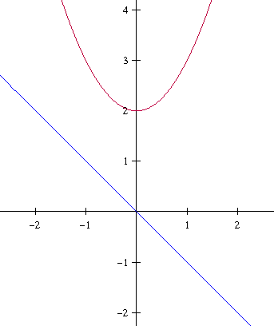

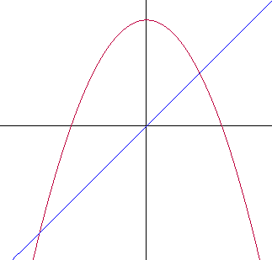**Example) A Region Lying Between Two Intersecting Graphs**Find the area of the region bounded by the graphs of f(x) = 2 – x2 and g(x) = x.

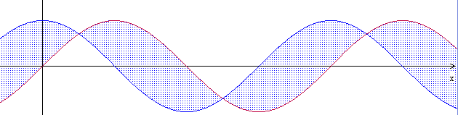**Example)**The sine and cosine curves intersect infinitely many times, bounding regions of equal areas. Find the area of each one of these regions.