Calculus Section 5.6 Inverse Trig Functions
-Develop properties of the six inverse trigonometric functions
Homework: page 372 #’s 3–13 odd, 15-20, 25–35 odd (Hint #35 take sin of both sides)
None of the six trig functions have inverses. Being periodic makes all of them fail to horizontal line test.
However, you can ___________________ the domain for the trig functions to allow them to have an inverse.
Inverse Trig Functions and Their Restricted Domains
arcsinx
arccosx
arctanx
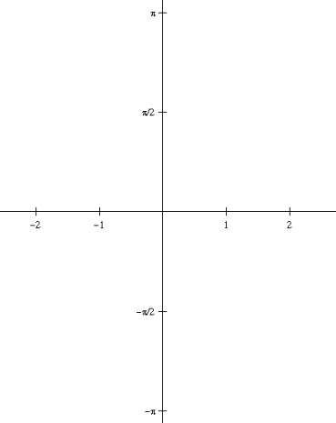

arccotx
arcsecx
arccscx

Examples
1) arcsin(-1/2) 2) arccos(0) 3) $arctan⁡\left(\sqrt{3}\right)$

4) arctan(2x – 3) = $\frac{π}{4}$ 5) Use a calculator to evaluate arccsc(2.590)

Using Right Triangles
4) Find cos(arcsin(x)) 5) Find $tan⁡\left(arcsec\left(\frac{\sqrt{5}}{2}\right)\right)$

