Calculus Section 4.1 Particular Solutions for Integrals Part II
-Use basic integration rules to find antiderivatives.
-Find a particular solution of an integral.
Homework: page 252 #’s 53, 54, 67,
61 <- also speeding up/slowing down
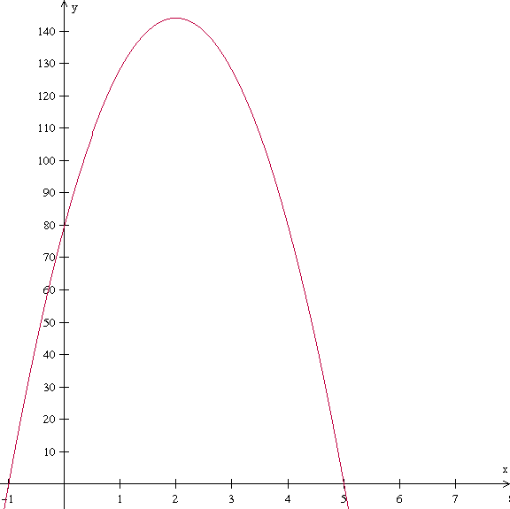
Example)
A ball is thrown upward with an initial velocity of 64 feet per second at an initial height of 80 feet. Find the position function giving the height as a function of time t. Next, find when the ball hits the ground. What is the velocity of the ball when it hits the ground? Use a = -32 as the acceleration due to gravity.

Example)
A particle moves along the x-axis at a velocity of $v\left(t\right)=t-\frac{1}{t^{2}}$. At time t = 1, the position is x = 3. Find the acceleration and position functions for the particle. When is the particle at rest? When is the particle moving to the left? When is the particle speeding up and slowing down?

