Calculus Section 3.4 Concavity and the Second Derivative Test

-Determine intervals on which a function is concave upward or concave downward  
-Find any points of inflection of the graph of a function  
-Apply the Second Derivative test to find relative extrema of a function

Homework: page 192 #’s 1, 2, 15, 17, 24, 33, 34, 50, 77, 78

**Definition of Concavity**Let *f* be differentiable on an open interval. The graph of *f* is _____________________ if is increasing on the interval and ____________________ if is decreasing on the interval.

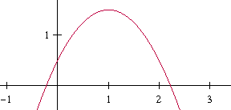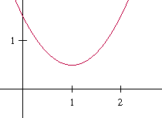

**Test for Concavity**  
Let *f* be a function whose second derivative exists on an open interval I.  
1) If for all x in I, then the graph of *f* is concave upward in I.  
2) If for all x in I, then the graph of *f* is concave downward in I.

**Example)**Determine the open intervals on which the graph of $f\left(x\right)=x^{4}-4x^{3}+2$ is concave upward or downward.

**Definition of Points of Inflection**Let *f* be a function that is continuous on an open interval and let *c* be a point in the interval. If the graph of *f* __________________________________ at that point, then this point is a **point of inflection** of the graph of *f*.

**Points of Inflection**  
If (c, f(c)) is a point of inflection of the graph of *f*, then either or does not exist at x = c.

**Example: Finding points of inflection**Determine the points of inflection and discuss the concavity of the graph of $f\left(x\right)=x^{\frac{2}{3}}(x-5)$.

**The Second Derivative Test**  
Let *f* be a function such that and the second derivative of *f* exists on an open interval containing *c*.  
1) If (concave up), then *f* has a __________________________ at (c, f(c)).  
2) If (concave down), then *f* has a __________________________ at (c, f(c)).  
3) If , then _______________________. It tells you NOTHING. You have to use the First Derivative Test instead. This does not mean that there is no max/min, the test just doesn’t work for that function.

**Example)**Use a tangent line at x = 1 to approximate f(1.1) for the function f(x) = 3x2 + 2. Tell whether the function is an overestimate or an underestimate. Justify your answer.