**Calculus Section 2.2 Rates of Change**

Homework: page 115 #’s 47-51 odd, 61, 70, 87-92, 97, 98, 101-105 odd

-Find the average velocity on an interval  
-Find the instantaneous velocity at a point

The function *s* that gives the position of an object as a function of time *t* is called a **position function**. If the object changes position over a period of time, , the **average velocity** is given by the formula:

average velocity =

Example) A tennis ball is dropped from a height of 100 feet, its height *s* at time *t* is given by the position function



where *s* is measured in feet and *t* is measured in seconds. Find the average velocity over the time interval.

1. [1,2]

Example) A particle is moving along the x-axis with the following positions and times given in the table below. Approximate the average velocity of the particle when t = 5.

|  |  |  |  |  |  |
| --- | --- | --- | --- | --- | --- |
| t (seconds) | 1 | 2 | 4 | 6 | 9 |
| x(t) (feet) | 5 | 7 | 13 | 20 | 25 |

The average velocities are negative. This indicates that the tennis ball is moving ___________________.

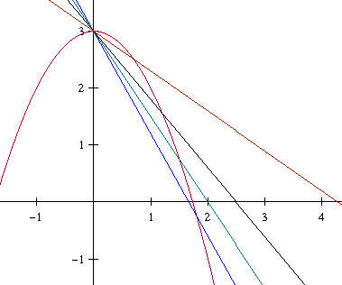**Position equation vs. Velocity**

As we decrease the interval used to find average velocity, we   
can find the **instantaneous velocity** of a function at a point.  
So,   
 In other words, the velocity is the ______________________ of the position function.Velocity is a **vector**, which means it has direction. So, velocity can   
be positive, negative, or zero. **Speed** is the absolute value of  
velocity, and cannot be negative.

Example)

At time t=0, a diver jumps from a platform diving board that is 32 feet above the water. The position of the diver is given by  where *s* is measured in feet and *t* is measured in seconds.

1. When does the diver hit the water?
2. What is the diver’s velocity at impact? What is their speed?
3. When does the diver stop moving upward and start their descent?