Calculus Section 1.5/3.5 Infinite Limits and Limits at Infinity  
- Determine vertical asymptotes  
- Properties of Infinite Limits  
- Determine horizontal asymptotes

Homework: pg 88 #’s 5, 7, 29, 30, 33-39 odd, 53, 55, 60  
pg 202 #’s 17-37 odd, 53, 54

A limit in which f(x) increases or decreases without bound as x approaches c is called an __________________.

Infinite limits, or , **do not exist**. We just say that the limit equals infinity so we can be more accurate in describing how the limit doesn’t exist. This is because a limit must equal a _____________________________________.

**Determining Vertical Asymptotes**

a.  b.  c. 

**Properties of Infinite Limits**Let and 

1. Sum or difference: 
2. Product:  if L > 0

 if L < 0

1. Quotient  

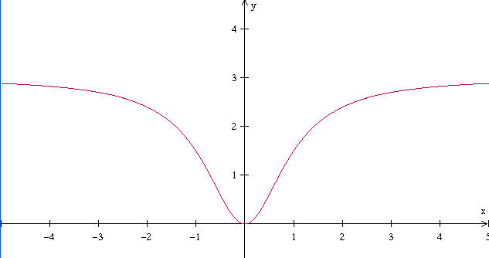

**Limits at Infinity**

Let   

|  |  |  |  |  |  |  |  |  |  |
| --- | --- | --- | --- | --- | --- | --- | --- | --- | --- |
| x |  | -100 | -10 | -1 | 0 | 1 | 10 | 100 |  |
| f(x) |  | 2.999 | 2.97 | 1.5 | 0 | 1.5 | 2.97 | 2.999 |  |

Finding the limit of a function at or at finds the “end behavior” of a function.

Theorem Limits at Infinity  
If r is a positive rational number and c is any real number, then



Examples)

a.  b.  c. 

**Infinite Limits with Trig Functions**

a.  b. 

**Graph and determine each value for ex and ln(x).**

f(x) = ex g(x) = ln(x)

f(0) = g(0) =

f(1) = g(1) =

 

 